DoDAF Operational & Systems Viewpoints

By Gary Bowman — Emerging Tech LLC — November 2022

**Operational Viewpoint** **2**

OV-1: High-Level Operational Concept Graphic 2

OV-2: Operational Resource Flow Description 2

OV-3: Operational Resource Flow Matrix 3

OV-4: Organizational Relationships Chart 3

OV-5a: Operational Activity Decomposition Tree 3

OV-5b: Operational Activity Model 3

OV-6a, 6b, 6c: Introduction 3

OV-6a: Operational Rules Model 3

OV-6b: State Transition Description 3

OV-6c: Event-Trace Description 4

**Systems Viewpoint** **4**

SV-1 Systems Interface Description 4

SV-2 Systems Resource Flow Description 4

SV-3 Systems-Systems Matrix 4

SV-4 Systems Functionality Description 4

SV-5a Operational Activity to Systems Function Traceability Matrix 4

SV-5b Operational Activity to Systems Traceability Matrix 4

SV-6 Systems Resource Flow Matrix 4

SV-7 Systems Measures Matrix 4

SV-8 Systems Evolution Description 4

SV-9 Systems Technology & Skills Forecast 4

Introduction to SV-10a, SV10b, and SV-10c 4

SV-10a Systems Rules Model 4

SV-10b Systems State Transition Description 5

SV-10c Systems Event-Trace Description 5

# Operational Viewpoint

## OV-1: High-Level Operational Concept Graphic

This is the highest level graphic of a system. It shows the connections between the parts of a system without actually detailing how these connections would function.

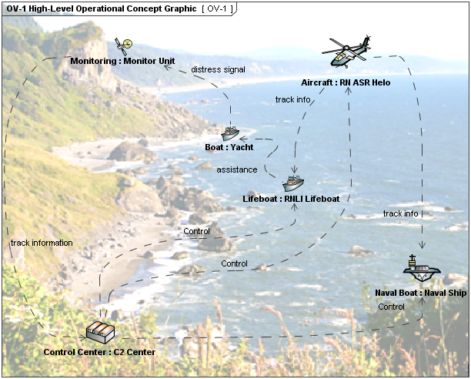

Figure 1: An example of a OV-1 created for NAVY

You can see in the figure above how there are simple 1 word descriptions given to each connection. This can help people without deep technical knowledge to get a general understanding of the system we are working on. Simplicity is important in some instances and this would be one of them.

## OV-2: Operational Resource Flow Description

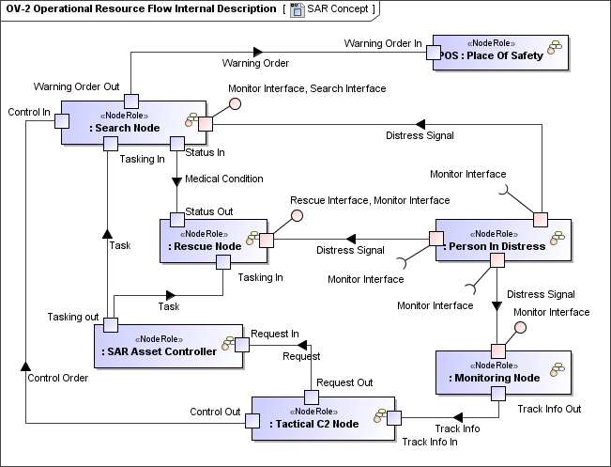

## OV-3: Operational Resource Flow Matrix

## OV-4: Organizational Relationships Chart

## OV-5a: Operational Activity Decomposition Tree

## OV-5b: Operational Activity Model

## OV-6a, 6b, 6c: Introduction

## OV-6a: Operational Rules Model

## OV-6b: State Transition Description

## OV-6c: Event-Trace Description

# Systems Viewpoint

## SV-1 Systems Interface Description

## SV-2 Systems Resource Flow Description

## SV-3 Systems-Systems Matrix

## SV-4 Systems Functionality Description

## SV-5a Operational Activity to Systems Function Traceability Matrix

## SV-5b Operational Activity to Systems Traceability Matrix

## SV-6 Systems Resource Flow Matrix

## SV-7 Systems Measures Matrix

## SV-8 Systems Evolution Description

## SV-9 Systems Technology & Skills Forecast

## Introduction to SV-10a, SV10b, and SV-10c

## SV-10a Systems Rules Model

## SV-10b Systems State Transition Description

## SV-10c Systems Event-Trace Description